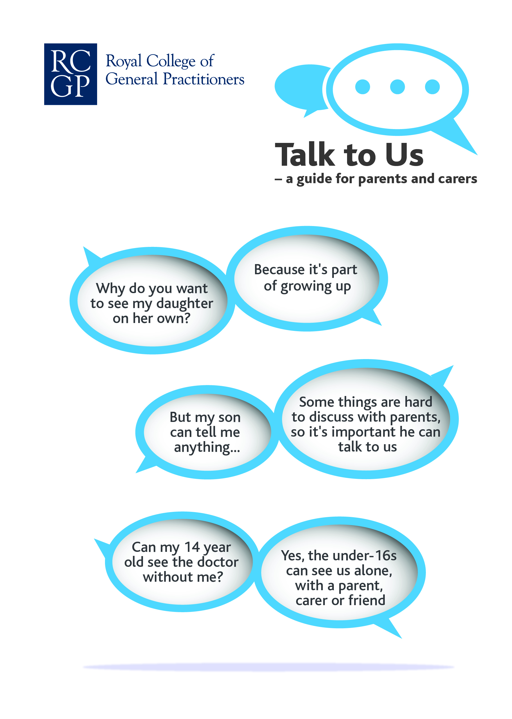

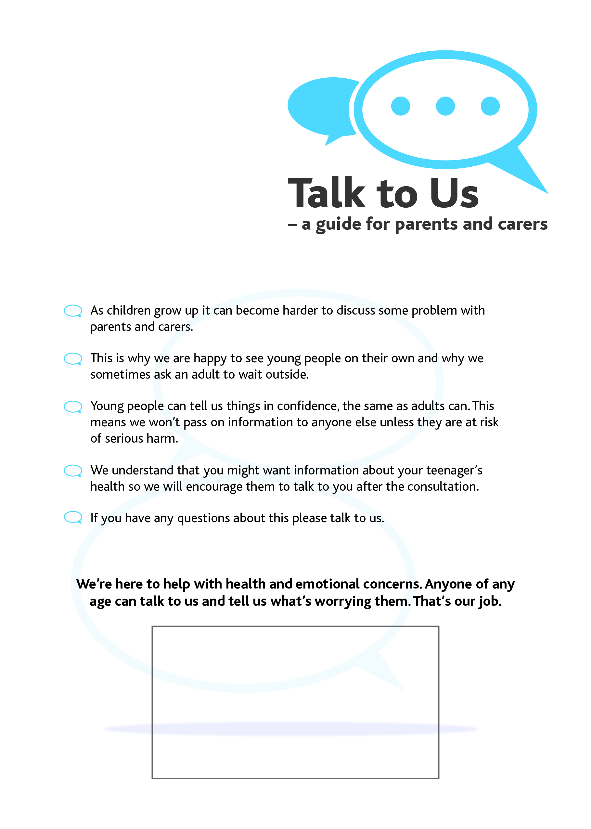

**Some useful websites:-**

<http://www.youngminds.org.uk>

<http://www.teenagehealthfreak.org>

<http://www.talktofrank.com>

<http://www.docready.org>

**Some useful apps:-**

WellMind – NHS mental health app

TeenSphere