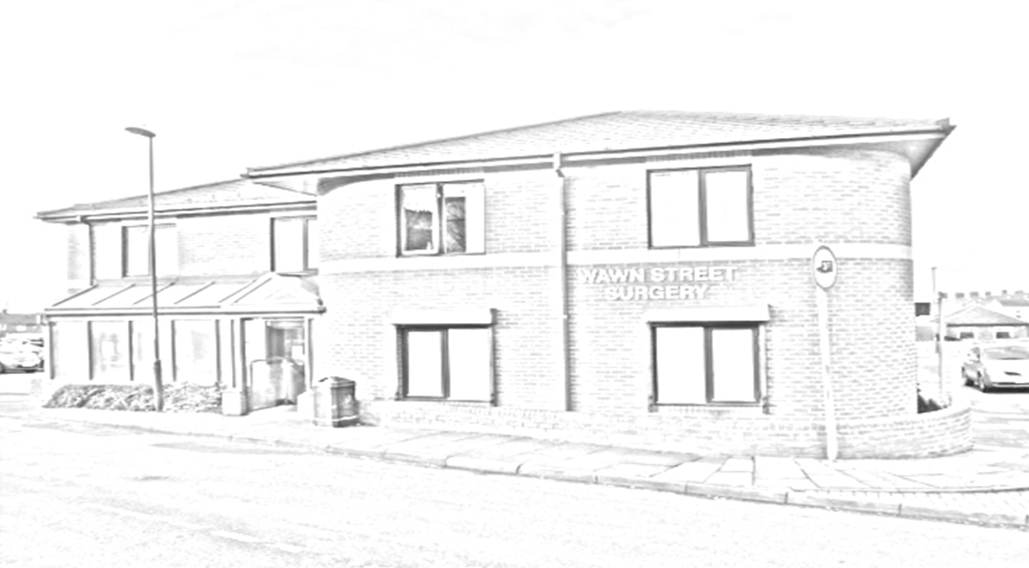
WELCOME TO WAWN STREET SURGERY

Our Mission Statement:
Primary and social care teams working together to empower good health through the sharing of responsibility for developing and delivering high quality, safe, patient focused services.

Our Vision:
We are a surgery that strives to provide high quality safe healthcare and excellence in customer service. We are a cohesive team that are resilient, innovative, forward thinking and committed to education.

Our Culture:

Embracing capability, opportunity and motivation to see our work through the eyes of the people who need our care. Harnessing patient input into design and delivery of services and demonstrating the best and most appropriate methods for improvement in quality and safety of health and wellbeing services

Our Values:
- Acknowledging that the patient is the core of our service
- Compassion
- Good quality, accessible care for all groups of patients
- Respect
- Value all feedback and opinions
- Committed to developing a well organised team with shared values
- Providing a safe environment that meets our patients’ needs

