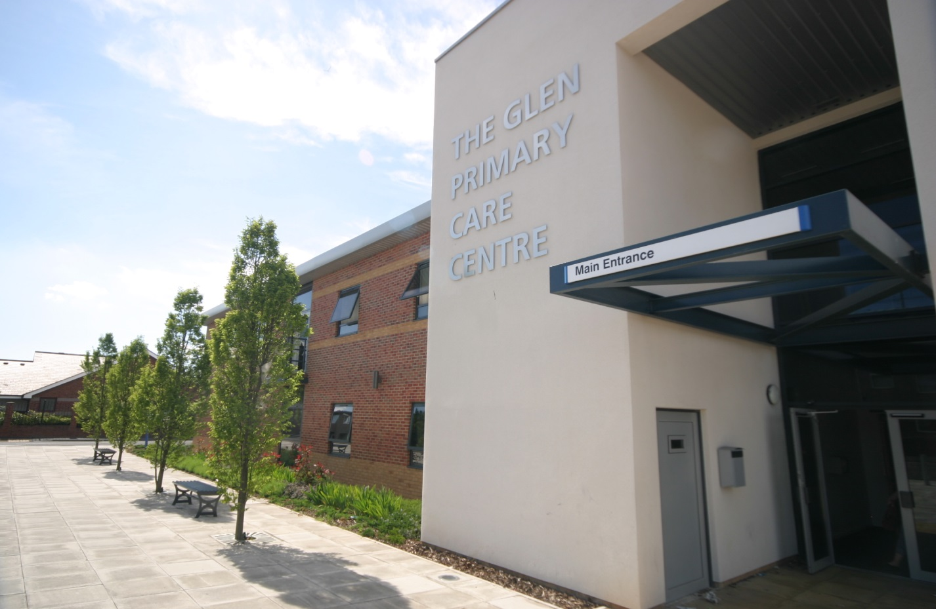

THE GLEN MEDICAL GROUP & THE PARK SURGERY

Patient Participation Annual Report
March 2017

INTRODUCTION
The history of our Patient Reference Group (previously called the patient forum) is documented in the report published 11/12. Since 2008 we have continued to recruit and develop. The aim of our group continues to be to:
- Share ideas for Practice development with our patients
- Discuss current topics within General Practice
- Assist at Practice open days/Patient Meetings
- Assist in resolving any practice problems
In March 2015 The Glen Medical Group took over the management of The Park Surgery. Both practices are now run side by side from the same premises. It was agreed that it would be more beneficial for the Patient Champions and the Patient Reference Groups from both Practices to join forces. The overall aim is that there is an equitable service provided across both practices and it made sense for a joint collaboration of groups.
Agreement of Priorities 2016/2017
Our joint Patient Reference Group met in July 2016 and agreed some priority areas to look at over the coming year.

As a group we felt the priority areas for the practice to improve are
- Teamwork – Sharing of priorities

- Young people – to focus on improving information and access for young people

- Wasted appointments – To significantly reduce DNA (Did not attend) numbers

- Website – To merge Practice websites

- Dementia – To achieve Dementia Friendly status and support the wider community project.

We agreed an action plan with aims and actions including responsibilities and timescales for work to be completed – see appendix 1

IMPLEMENTATION OF THE ACTION PLAN

We worked through the action plan and the status of the actions is as follows

Team work
Joint priorities were shared with the full practice team and updates discussed at our regular monthly team meetings.

Young people
We appointed one of our receptionists as dedicated Young person’s champion and she created a dedicated notice board with specific young person’s services and information. She keeps this up to date and also adds relevant information to the website. She also keeps the rest of the team informed of changes to services or new services available in the area.

We did initially plan to survey our patients age between 16-24, however the feedback from both the PPG and some of our own staff within that age cohort was that they probably would not return the survey. We therefore changed this to a specific newsletter with information and services relevant to this age group. We have left an option for feedback if the patients have any or wish to contact us with any questions.

We also wrote to local comprehensive schools informing them that we were keen to engage with young people. We gave details of the ‘Young persons’ project and our practice champion details and asked if the schools were interested in working with us on this project. Unfortunately we did not receive a response from either school to date but do intend to chase this up again.

Appointments – Did not attend
We reintroduced our ‘Did not attend policy’ writing to patients who miss appointments and in some cases removing persistent non-attenders form the practice register.

We spent a significant amount of time completing a DNA audit. This involved ringing patients and collecting data as to why they did not attend or cancel their appointments. The results of this were quite shocking showing that on average we are losing 1.7 sessions of GP time and 11 hours of practice nursing time each week due to missed appointments. We incorporated this work into some work we have been doing as part of The General Practice improvement scheme and our facilitator helped us interpret and produce the results. The whole report can be found in appendix 2.

We have shared with the team and will address the resulting actions over the next few weeks.

Websites
We have spoken to our website providers and the Glen website will be updated to incorporate the information for both practices from April onwards. The contract for the Glen website continues until May however it will not be updated as this is a duplicate of work and not best use of staff time. A message will be on the website for a short time re directing patients to the new joint website.

Dementia
The Practice achieved Dementia friendly status and all staff completed the Dementia friends training. Our Dementia champion attends the Hebburn meetings as part of the wider dementia friendly Hebburn project.

PUBLICISING INFORMATION

We plan to publicise this report on our Practice website along with the minutes from our Patient Reference Group meetings.
We will also highlight the changes we have made and all the information required for our patients to access these services via our

Practice Leaflet
Quarterly Newsletter
Practice Website
NHS Choices Website
Patient call in screen in waiting room
Poster in waiting room

A Note from The Glen Medical Group & Park Surgery

We would like to thank the Patent Participation Group and also the Patient Champion members for their time, commitment and valuable input working with us for continuous improvements to our service.

Appendix 1

The Glen Medical Group/Park Surgery
Practice priorities (agreed with PPG) - Action Plan 2016-17 August 2016
Title | Aim | Planned action | By Whom | Date to be completed
Team work | To share priorities with team and patients | - Discuss priorities with team and agree shared goals and individual responsibilities  - Share priorities with patients | LC | Sept 16
Young People | To focus on Young people improving information/access | - Survey targeted Young person’s cohort to gain their views  - Promote Young person’s services  - Possible liaison with local schools /school Nurse  - Allocated website area  - Allocated notice board  - Whole practice to Promote practice social media to this cohort of patients.  - Appoint non clinical Young person’s champion (reception team) | LC | March 17
Appointments – Did not attend | To significantly reduce DNA numbers | - To re-introduce our previous DNA policy  - To inform patients  - To publicise weekly data re missed appointments  - Improve/increase ways for patients to cancel appointments, PPG suggestions include  - Separate telephone number for cancellations  - Add number to appointments cards  - Publicise via all outlets – website/ scripts/letters/social media/waiting room  - To remove patients who abuse the appointment system | LC | March 17
Website | To merge practice websites  To improve information | - To merge websites at next renewal date  - Allocate 1 member of staff to be responsible for updating  - Create/improve information for young person cohort (as above)  - Keep information for patients up to date and relevant |  | March 17
Dementia | Practice to achieve Dementia friendly status – in line with the wider community pilot | - All staff to complete dementia friend training  - To appoint non clinical Dementia friend champion (reception team) to drive Dementia friendliness throughout the surgery. This will include checking the environment and offering support/signposting  - To support Dementia friendly Hebburn initiative where possible | LC | March 17

Appendix 2
THE GLEN MEDICAL GROUP

DNA AUDIT REPORT

Audit carried out by:
Chantelle Farrington
Emma Andersen

Report:
Jane Fisher

The Glen and Park Practice Lists - DNA Audit
Week Commencing 23rd January 2017

Introduction
As part of their monitoring processes, the Glen Medical Group followed up by telephone, all the DNAs from week commencing 23rd January to explore the reasons why patients did not attend their planned appointments with GPs, Nurses and Healthcare Assistants (HCAs). This was to help identify potential opportunities to reduce the incident of DNAs and thereby increase the capacity of both the GP and nursing staff. The results of the surveys are summarised below.

Results

The Park: Total Patients: 23

Sex | Age | Reason | Other / Additional Info | Mobile / Landline: | Date Appt Booked | Date of Appt | Days be-tween | Clinician | Another Appt Made | No of DNA's
Female | 16 | Used alternative service |  | Mobile | 26.01.2017 | 26.01.2017 | 0 | GP | No | 1
Female | 29 |  | No text received | Mobile | 10.01.2017 | 24.01.2017 | 14 | GP | No | 1
Male | 41 |  |  | Mobile | 11.01.2017 | 27.01.2017 | 16 | Nurse | No | 1
Female | 28 |  |  | No no. | 20.01.2017 | 24.01.2017 | 4 | GP | Yes | 2
Male | 61 |  |  | Mobile | 05.12.2016 | 27.01.2017 | 53 | Nurse | No | 2
Male | 66 | Admitted to hospital |  | Landline | 06.01.2017 | 26.01.2017 | 20 | Nurse | No | 1
Female | 23 | Forgot |  | Mobile | 30.12.2016 | 23.01.2017 | 24 | Nurse | Yes | 2
Female | 51 |  |  | Mobile | 05.01.2017 | 26.01.2017 | 21 | Nurse | No | 2
Female | 26 | Staff error |  | Mobile | 20.01.2017 | 23.01.2017 | 3 | GP | Yes | 1
Male | 30 | Forgot |  | Mobile | 20.01.2017 | 26.01.2017 | 6 | HCA | No | 2
Female | 72 | Other (state) | Had fall - injury | Landline | 05.12.2016 | 27.01.2017 | 53 | Nurse | Yes | 1
Female | 45 |  |  | Landline | 18.01.2017 | 25.01.2017 | 7 | GP | No | 2
Female | 37 | Unable to contact to cancel |  | Mobile | 09.01.2017 | 24.01.2017 | 15 | Nurse | Yes | 2
Female | 35 |  |  | Mobile | 19.12.2016 | 25.01.2017 | 37 | Nurse | No | 2
Female | 26 | Forgot | Death in Family | Mobile | 13.01.2017 | 27.01.2017 | 14 | GP | Yes | 1
Male | 40 | Forgot | No text received | Mobile | 24.01.2017 | 26.01.2017 | 2 | GP | Yes | 1
Male | 42 | Forgot |  | Mobile | 18.01.2017 | 24.01.2017 | 6 | HCA | No | 1
Female | 35 |  |  | No no. | 08.12.2016 | 23.01.2017 | 46 | Nurse | No | 1
Male | 75 | Forgot |  | Landline | 19.12.2016 | 23.01.2017 | 35 | Nurse | Yes | 1
Female | 64 | Unable to contact to cancel |  | Mobile | 19.12.2016 | 23.01.2017 | 35 | Nurse | Yes | 1
Male | 62 |  | Did not want to attend | Mobile | 05.12.2016 | 27.01.2017 | 53 | Nurse | No | 2
Female | 31 | Unable to contact to cancel |  | Mobile | 20.12.2016 | 24.01.2017 | 35 | Nurse | No | 2
Female | 62 | Forgot | Booked appt in advance | Landline | 25.01.2017 | 27.01.2017 | 2 | GP | Yes | 2

The Glen: Total Patients: 41
Sex | Age | Reason | Other / Additional Info | Mobile / Landline No: | Date Booked | Date of Appt | Days between | Clinician | Another Appt Made | No of DNA's
Female | 16 |  |  | Mobile | 19.01.2017 | 23.01.2017 | 4 | GP | No | 3
Female | 51 | Staff error | patient did not book this appt? | Mobile | 03.01.2017 | 24.01.2017 | 21 | GP | Yes | 2
Female | 69 | Staff error | Patient did not book this appt? | Landline | 21.12.2017 | 23.01.2017 | 54 | Nurse | No | 1
Male | 55 | Unable to contact to cancel | Couldn't attend due to time of appt | Mobile | 28.12.2017 | 27.01.2017 | 58 | Nurse | Yes | 1
Female | 28 |  |  | Mobile | 12.01.2017 | 25.01.2017 | 13 | GP | No | 2
Female | 49 |  |  | Mobile | 28.12.2016 | 26.01.2017 | 57 | Nurse | No | 1
Female | 15 | Earlier appointment | Given emergency appt 17.01.2017 | Mobile | 09.01.2017 | 24.01.2017 | 15 | GP | No | 1
Female | 41 | Forgot | Received text reminder | Mobile | 18.01.2017 | 24.01.2017 | 6 | Nurse | Yes | 1
Female | 21 | Unable to contact to cancel |  | Mobile | 09.01.2017 | 23.01.2017 | 14 | GP | No | 1
Female | 29 | Unable to contact to cancel | child was very unwell | Mobile | 20.01.2017 | 26.01.2017 | 6 | GP | No | 1
Female | 18 | Staff error | Communication - see consultation if needed | Landline | 26.01.2017 | 26.01.2017 | 0 | GP | Yes | 2
Female | 24 | Forgot | Didn't need appointment anymore | Mobile | 05.01.2017 | 26.01.2017 | 21 | Nurse | No | 1
Male | 50 | Used alternative service | A&E / Crisis Team 24.01.2017 | Mobile | 12.01.2017 | 25.01.2017 | 13 | GP | No | 1
Male | 67 | Forgot | No text reminder - now set up | Landline | 30.12.2017 | 27.01.2017 | 58 | Nurse | Yes | 1
Female | 70 | Forgot | Doesn't have a mobile for text reminder | Mobile | 13.01.2017 | 23.01.2017 | 10 | HCA | Yes | 1
Male | 53 | Unable to contact to cancel | Text surgery number to cancel - was unwell | Mobile | 16.01.2017 | 27.01.2017 | 11 | HCA | Yes | 1
Female | 18 | Forgot | Received text reminder | Mobile | 23.01.2017 | 25.01.2017 | 2 | GP | No | 1
Female | 32 | Staff error | Patient declined appointment - had text reminder | Mobile | 17.01.2017 | 24.01.2017 | 7 | Nurse | No | 1
Female | 92 | Forgot | Doesn't have a mobile for text reminder | Landline | 21.12.2016 | 26.01.2017 | 57 | Nurse | No | 1
Female | 51 | Forgot | Got mixed up with appointment date | Mobile | 09.01.2017 | 27.01.2017 | 16 | GP | Yes | 1
Female | 69 | Staff error | Insists did not have an appointment | Mobile | 10.01.2017 | 24.01.2017 | 14 | HCA | No | 1
Female | 27 | Staff error | patient claims to have cancelled the appointment | Mobile | 09.01.2017 | 24.01.2017 | 15 | Nurse | Yes | 2
Male | 27 | Forgot | Said didn't even book appointment - had text reminder | Mobile | 09.01.2017 | 24.01.2017 | 15 | GP | No | 1
Female | 64 | Forgot | No text reminder - now set up | Mobile | 28.11.2017 | 24.01.2017 | 85 | Nurse | No | 1
Female | 23 |  |  | Mobile | 13.01.2017 | 24.01.2017 | 11 | Nurse | Yes | 2
Male | 44 | Forgot | No text reminder - now set up | Mobile | 28.11.2017 | 26.01.2017 | 87 | Nurse | Yes | 1
Male | 69 |  |  | Mobile | 23.01.2017 | 25.01.2017 | 2 | Nurse | Yes | 1
Male | 56 |  | No mobile number - has landline. | Landline | 09.12.2016 | 26.01.2017 | 57 | HCA | Yes | 1
Male | 20 |  |  | No number | 11.01.2017 | 25.01.2017 | 14 | GP | No | 3
Male | 48 | Forgot | Slept in. | Mobile | 24.01.2017 | 27.01.2017 | 3 | GP | Yes | 2
Male | 58 | Forgot | No text reminder - now set up | Mobile | 20.12.2016 | 26.01.2017 | 57 | Nurse | Yes | 2
Female | 31 | Unable to contact to cancel | Called into work - tried to call, could not get through. | Mobile | 18.01.2017 | 26.01.2017 | 8 | GP | No | 2
Female | 28 | Staff error | We called patient to cancel? Unsure why? | Mobile | 13.01.2017 | 27.01.2017 | 14 | GP | Yes | 1
Male | 62 |  | Arrived late - got seen in cancellation same day | Mobile | 25.01.2017 | 27.01.2017 | 2 | GP | Yes | 1
Female | 69 | Staff error | Given wrong appointment time via reception. | Landline | 21.12.2017 | 26.01.2017 | 57 | Nurse | Yes | 1
Female | 30 |  |  | Mobile | 10.01.2017 | 25.01.2017 | 14 | GP | No | 1
Male | 24 |  |  | No number | 12.01.2017 | 25.01.2017 | 13 | GP | No | 1
Male | 47 |  |  | Mobile | 19.01.2017 | 23.01.2017 | 4 | GP | No | 1
Female | 72 | Forgot | No text reminder - now set up | Mobile | 05.12.2016 | 24.01.2017 | 55 | Nurse | Yes | 1
Male | 27 |  |  | No number | 09.01.2017 | 23.01.2017 | 15 | GP | No | 1
Male | 36 |  | No text reminder - now set up | Mobile | 24.01.2017 | 27.01.2017 | 3 | GP | Yes | 2

Data for both Practices

Analysis

Key Observations – considering the whole Glen Medical Group:

- 29 GP appointments were lost due to DNAs in this week, with a further 35 nursing/HCA appointments lost.

- Missed appointments equate to 1.7 GP sessions and 11.7 hrs of nursing time lost, based on 17 appointments per GP session and an average 20-minute Nurse/HCA appointment respectively.

- The key reasons stated for DNAs offered by the patients surveyed were: ‘forgot’ and staff error’, with a proportion stating that they could either ‘could not contact the surgery / get through to the surgery’.

- 62% of the patients who did not attend were women,

- 45% of the appointments missed were those with GPs, 65% being with nursing/HCA staff.

- This was the second DNA in 12 months for 31% of the patients concerned, with only a small proportion (3%) on their third DNA – the latter at risk of being taken off the Practice List.

- Considering the age of the DNA patients, there was a peak of those within the age range of 26-30 (c.19%), although there was representation across all the age bands between 16-75.

- The time between the date on which an appointment was made and the actual day of the appointment varied, although 2 sets of distributions were identified across:
  - 2-24 days and
  - 53-57 days.
The longer time frames reflect those made with a nurse, for example for Reviews of chronic conditions, with the majority of shorter time frames relating to GP appointments. Interestingly, two appointments were ‘forgotten’ when they had actually been made on the same day as the appointment.

The data provided has offered the Glen Medical Group an opportunity to identify strategies that will help them to reduce their DNAs and therefore increase their Capacity. These are based primarily around:

- A review of Reception Practices and Processes, with the aim of updating their approaches and refreshing the team with regard to their responsibilities, particularly around answering the phones with regard to patient appointments.

- Introducing a new telecommunications system – March 2017, which will include a range of automated systems – for example the booking and cancellation of appointments, whilst offering improved messaging re: appointments to patients and the opportunity for patients to cancel their appointment by text, as well as supporting Reception staff through the recording/monitoring of phone calls, to ensure all telephone processes are embedded effectively

Key Recommendations – see Action Plan overleaf
To be monitored via:
= Understood
= Underway
= Complete
= Sustained

 | Action | Who | By When | Progress | Initials
1 | “Staff Error” & “No Telephone Number”  Review Reception Staff Responsibilities and Processes to ensure:  - they check the telephone number of patients – along with other data  - patient appointment clarifications are made | Practice Manager
2 | “Staff Error” & “No Telephone Number”  Draft a Processes Diagram for Reception Staff | Facilitator
3 | “Staff Error” & “No Telephone Number”  Meet with staff to explain requirements | Practice Manager
4 | “Forgot” and “Could not contact the surgery / get through to the surgery”  New telecommunications system to be introduced – to include:  Automated actions, such as appointment bookings & cancellations, e- and text messaging, recording/monitoring facilities | Practice Manager

