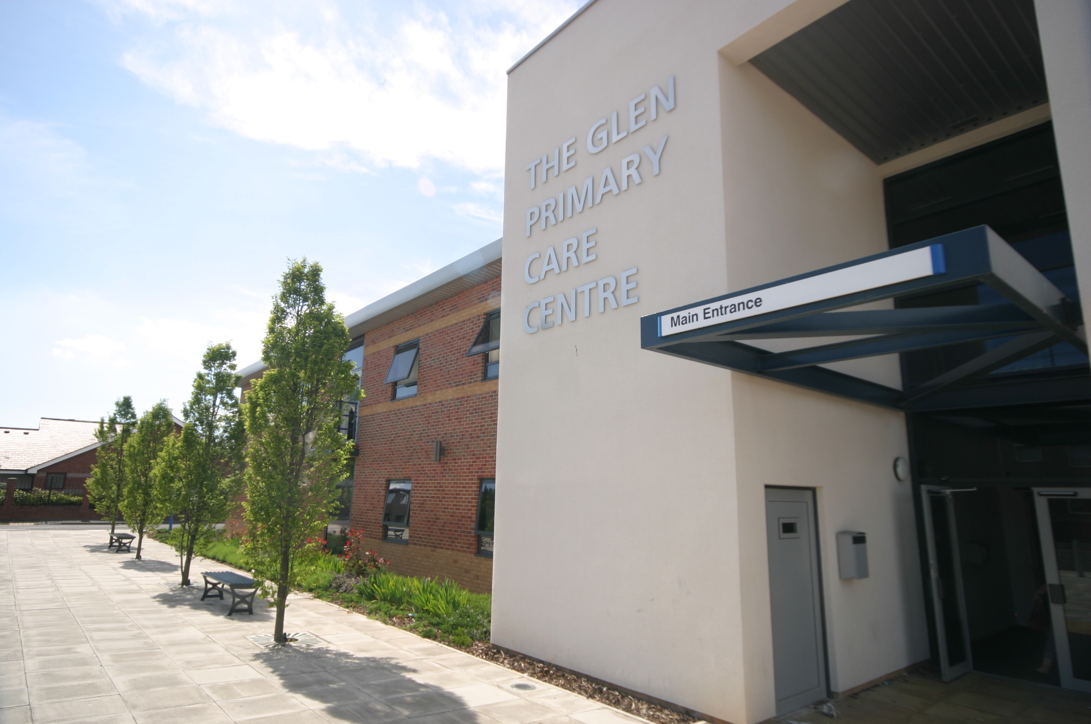

THE GLEN MEDICAL GROUP

Patient Participation Annual Report
March 2015

INTRODUCTION
The history of our Patient Reference Group (previously called the patient forum) is documented in the report published 11/12. Since 2008 we have continued to recruit and develop. The aim of our group continues to be to:
- Share ideas for Practice development with our patients
- Discuss current topics within General Practice
- Assist at Practice open days/Patient Meetings
- Assist in resolving any practice problems
Agreement of Priorities
Our patient reference group meets quarterly. We met in June and September 14 and agreed some priority areas to look at over the coming year.
As a group we feel the priority areas for the practice to improve are
- To recruit some younger members for the PRG
- To continue with our Practice IT initiative
- To work with our patient champions to progress to the next step and see groups/activities up and running

Implementation of the Action Plan

Recruitment

PRG members suggested we contact local 6th form college to try and recruit younger members to gain their views. A letter was sent to head of 6th form with a poster asking for interested students to contact the surgery. We successfully recruited two 6th form students from this and they have joined us at our PRG meetings.

IT Initiative

We enlisted the help of one of our PRG members who also works for Age UK and kindly arranged a couple of ‘pop up’ sessions in the waiting room to promote how IT can be used for such things as accessing health information, booking appointments and ordering prescriptions. This was successful and we hope to arrange some further sessions throughout the year. We organised a representative from Health Action Station to come in to the waiting room every fortnight and they opportunistically showed interested patients the benefits of having online access and promoted the use of the internet to access health information etc.
We have not yet purchased the IPads for GP visits as there were a few IT issues with connection which we wanted to clarify with the clinical system provider to ensure it was a workable system before spending money on IPads. We are currently waiting for a live demo from them.

Patient Champions

This has by far been our biggest piece of work and taken a fair bit of time to get up and running, however we do feel that it is just now becoming established and we are seeing some positive results. There is an element of crossover with the PRG with some of our patients joining both and offering to come in their various ‘day job’ roles to give talks/ advice to patient champion groups. The Champions did a patient survey and included some suggestions from the PRG members i.e. ‘time to talk’ groups within the survey to gain ideas from the patients about what they would be interested in joining. We gave surveys out at reception and the champions came along to our 3 Saturday morning flu clinics in October to chat informally to patients and ask views. The results were collated and the most popular choices were:

Time to talk
Childrens keep fit
Gentle exercise class
Weigh & walk

All four of the above groups are now up and running albeit some more established than others. The gentle exercise class has proved very popular and is getting a good turnout every week. The weigh in is also popular with the patients swapping healthy recipes and losing weight! The champions realised that there is already currently a local walking group organised by South Tyneside Groundworks, they intend to look into working with them to join the already established walking group. The childrens exercise class is run by one of our champions who has a keen interest in childrens health and already holds all the relevant qualifications and checks.

We met with the PRG again in February 2015 and discussed the progress of the above priorities as well as other practice news and updates. This report will be shared with our PRG via email and discussed at the next PRG meeting due to be held May 2015.

PUBLICISING INFORMATION

We plan to publicise this report on our Practice website along with the minutes from our Patient Reference Group meetings.
We will also highlight the changes we have made and all the information required for our patients to access these services via our

Practice Leaflet
Quarterly Newsletter
Practice Website
NHS Choices Website
Patient call in screen in waiting room
Poster in waiting room

A Note from the Glen Medical Group

We would like to thank the Patent Reference Group and also the Patient Champion members for their time, commitment and valuable input working with us for continuous improvements to our service.

