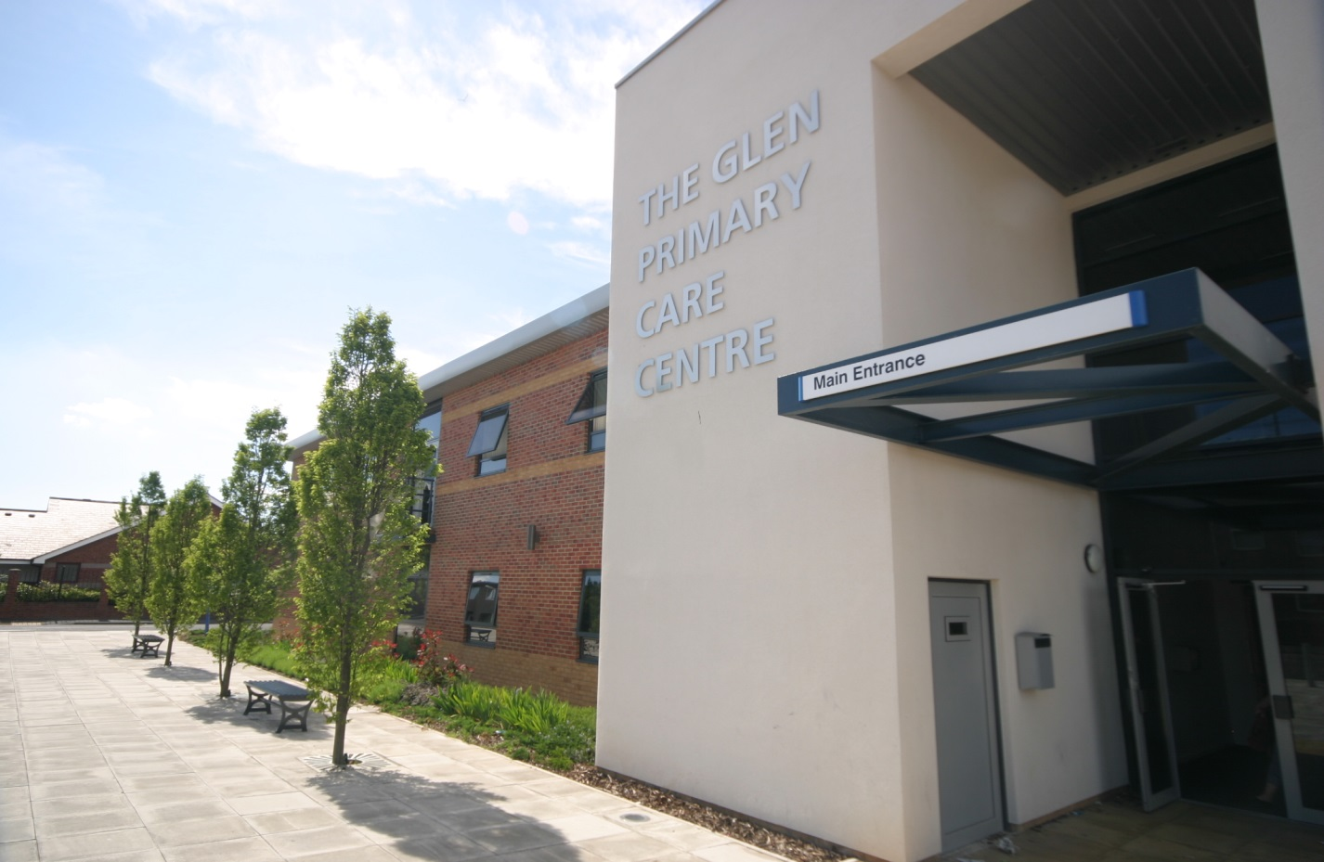

THE GLEN MEDICAL GROUP

Patient Participation Annual Report
March 2016

INTRODUCTION
The history of our Patient Reference Group (previously called the patient forum) is documented in the report published 11/12. Since 2008 we have continued to recruit and develop. The aim of our group continues to be to:
- Share ideas for Practice development with our patients
- Discuss current topics within General Practice
- Assist at Practice open days/Patient Meetings
- Assist in resolving any practice problems
Since the last report was submitted The Glen Medical has taken over the management of The Park Surgery. Both practices are now run side by side from the same premises. It was agreed that it would be more beneficial for the Patient Champions and the Patient Reference Groups from both Practices to join forces. The overall aim is that there is an equitable service provided across both practices and it made sense for a joint collaboration of groups.
Agreement of Priorities
Our joint Patient Reference Group met in July 15 and February 16 and agreed some priority areas to look at over the coming year.
As a group we felt the priority areas for the practice to improve are
- Recruitment of new PRG members across both practices
- Implementation of a 24 hour prescription line
- Improve ‘Front of House’ experience
- Car Park barrier

IMPLEMENTATION OF THE ACTION PLAN

Recruitment of new PRG members

We have advertised for new members via posters in our waiting area asking patients to submit an application. We ran a patient survey which was developed in conjunction with our PRG in which one of the questions was: are patients aware of our ‘Patient Champions’ and ‘Patient Reference Group’ and would they would be interested in becoming members. Those that responded were sent application forms and these are currently being reviewed. It was agreed that there should be an equal number of representatives from both practices. It was also hoped that a ‘virtual members’ group could be established and the practice is actively encouraging patients to give their email address so that a wider audience can be reached.

24 Hour Prescription Line

Previously the prescription line was only open for 1 hour per day which meant that patients would ring the main line with queries resulting in the line being very busy. Approximately 50% of calls made to the practice were related to prescription queries. Members suggested the implementation of a 24 Hour prescription line. On liaising with the telecoms agency the line was set up so that patients could call and leave their details and request for medication. This new facility was advertised via our website, posters on our patient information board in reception, notice on repeat prescriptions and staff informing patients ad hoc. This has now been running for a number of months and has proven to be very successful with the number of requests gradually increasing.

Improve ‘Front of House’ experience

Following the joining of the 2 Practices queues at the front reception desk had increased considerably. Members had noted that many patients just wanted to hand in repeat prescription requests but had not noticed that there was a box on the reception desk to place them in without having to queue. It was agreed to improve signage regarding this. Also patients attending appointments with other services in the building often queued at The Glen reception instead of the reception desk upstairs. Again it was agreed to introduce better signage. One member suggested using a ‘queue buster’ who could signpost patients to the right queue or help them use the self-check in service. A couple of Patient Champions volunteered to help with this, unfortunately the times that they came in, the waiting room was not particularly busy and no immediate benefit was felt. It was agreed we would trial this again at a later date.

A further idea of a ‘ticket system’ was suggested whereby a patient takes a ticket on arrival and then takes a seat and waits to be called to the desk. It was felt this would also help with confidentiality at the desk and also benefit older patients who will not have to stand for long periods of time. This idea has been put on hold at present as a new check in system has been installed and we are waiting to see if this has an impact on queues.

Car Park Barrier

A few of the members stated that they had had to wait several minutes for the buzzer to be answered and the barrier to be raised when entering the car park. The intercom for this is situated at the front reception desk where there were usually at least 1 – 2 members of staff on duty. However at busy times they may need to leave the desk to deal with a query. One of the PRG members stated he had installed an additional intercom for another practice and had a spare one. He agreed to come and fit this in the reception back office where other staff members could access it as well and therefore increase the number of staff able to activate the buzzer.

PUBLICISING INFORMATION

We plan to publicise this report on our Practice website along with the minutes from our Patient Reference Group meetings.
We will also highlight the changes we have made and all the information required for our patients to access these services via our

Practice Leaflet
Quarterly Newsletter
Practice Website
NHS Choices Website
Patient call in screen in waiting room
Poster in waiting room

A Note from the Glen Medical Group

We would like to thank the Patent Reference Group and also the Patient Champion members for their time, commitment and valuable input working with us for continuous improvements to our service.

