Dr Malhotra & Partners

Pike View Medical Centre
Albert Street
Horwich
Bolton
BL6 7AS

Tel: 01204 322888

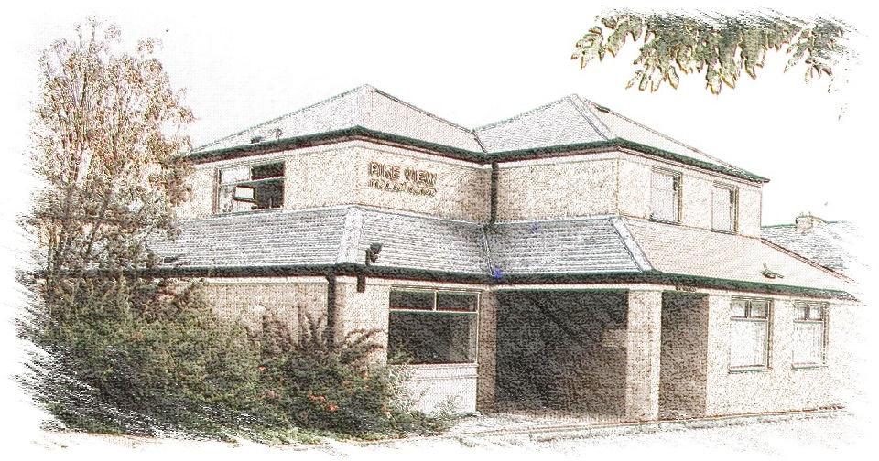

Complaints Procedure

Practice Complaints Procedure
If you have any complaint or concern about the service you have received from the doctors or staff working for this surgery you are entitled to ask for an explanation. We operate an informal, in house procedure to deal with your complaints. This procedure does not deal with matters of legal liability or compensation. In some cases the in-house procedure is not an appropriate form of investigation, in which case you will be referred to the appropriate authority. This procedure does not affect your right to make a formal complaint to NHS England if you so wish. Nor does it affect your right to seek compensation in law.

How to complain
We hope that most problems can be sorted out easily and quickly, often at the time they arise and with the person concerned. If this is not possible and you wish to make a complaint, we would like you to let us know as soon as possible. This will enable us to establish what happened more easily. If it is not possible to do that, please let us have details of your complaint:
- Within twelve months of the incident that caused the problem OR
- Within twelve months of discovering that you have a problem
Your complaint should be addressed to the Practice Manager who will ensure that it is investigated thoroughly and as speedily as possible. It will be a great help if you are as specific as possible about your complaint and any outcomes you would like to see.

What Happens Next?
We will acknowledge your verbal or written complaint within three working days. You will be offered the opportunity to discuss and agree a plan of how the complaint will be handled either by telephone or in a meeting. When we look into your complaint we shall aim to:
- Find out what happened and what went wrong
- Make it possible for you to discuss the problem with those concerned, if you would like this
- Make sure you receive an apology, where this is appropriate
- Identify what we can do to make sure the problem does not happen again
If you wish to complain on behalf of someone else we cannot disclose any confidential information without the appropriate authority. If you need help with your complaint please contact the Practice Manager.

Someone within the surgery will then investigate your complaint. It is likely that, as a first step, the investigator will contact you directly to ensure that he/she fully understands your complaint. The investigator will then interview appropriate members of the practice staff and may inspect relevant documents. You will be contacted again with the outcome of the investigation within 10-25 working days of the date from when you raised the complaint with us.

Getting further help with your complaint
We hope that, if you have a problem, you will use our practice complaints procedure. We believe this will give us the best chance of putting right whatever has gone wrong and an opportunity to improve our practice. At the conclusion of the investigation your complaint will be discussed with you in detail.

You can get advice and support from the following:
Healthwatch Bolton
Telephone 01204 372842
Email: info@healthwatchbolton.co.uk

Parliamentary and Health Service Ombudsman
Millbank Tower
Millbank
London
SW1P 4QP

Tel: 0345 015 4033
E-mail: phso.enquiries@ombudsman.org.uk
Fax: 0300 061 4000

If you are dissatisfied with the result of our investigation you may request an independent review by the Health Service Ombudsman within 6 months of the date of your final response.

Independent Complaints Advocacy
5th Floor Arthur House
Chorlton Street
Manchester
M1 3FH
Tel: 0808 801 0390
E-mail: Manchesterica@carersfederation.co.uk

NHS England
Telephone 0300 311 2233
Email: england.contactus@nhs.net

